DOCKER TASK

Q: Install docker on EC2 and explore the docker commands (docker images, containers, volumes, network)

OUTPUTS:

Initially launched an instance-dockertask

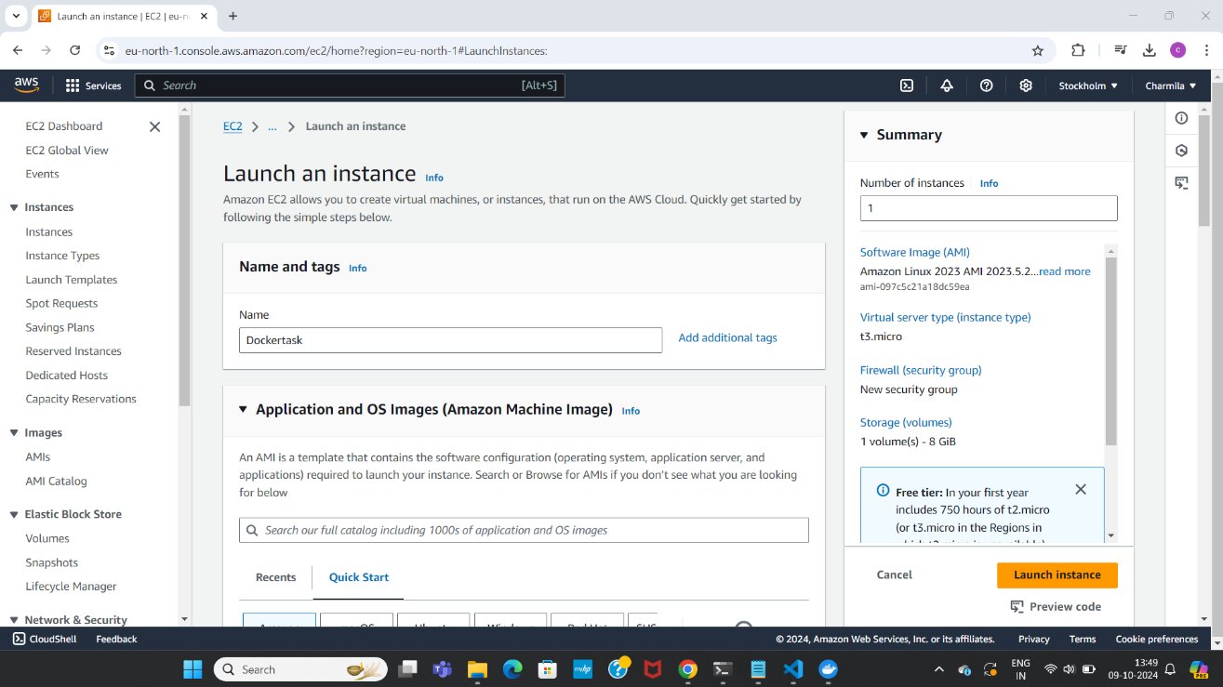

Created a new keypair and launched the instance

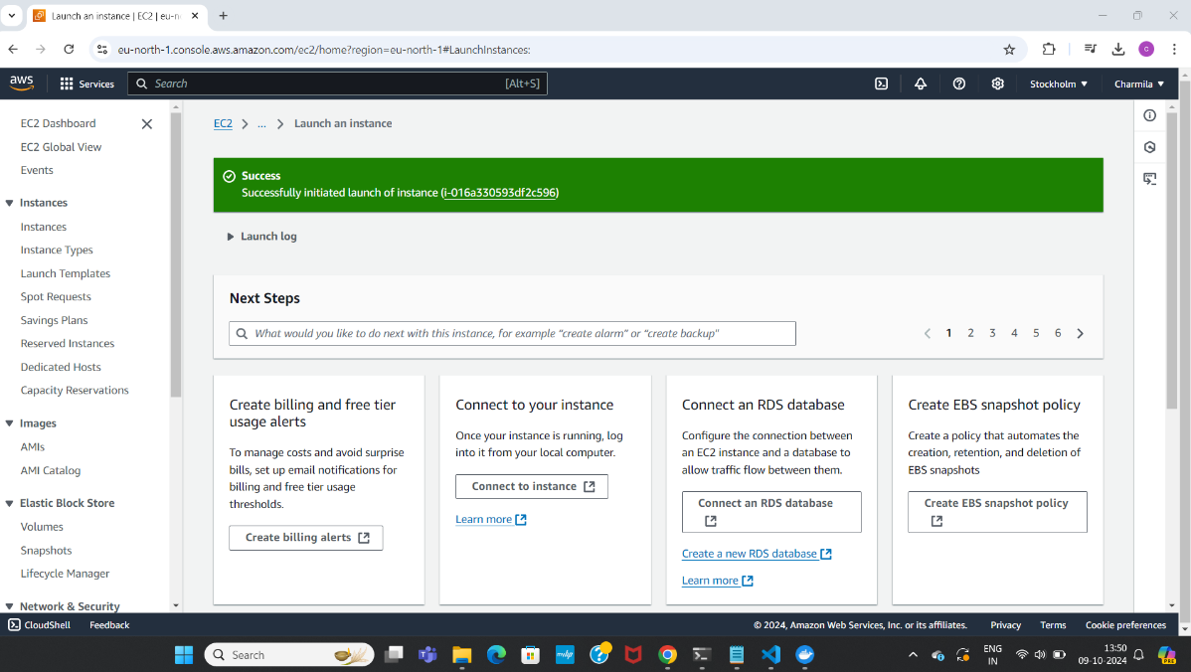nstance

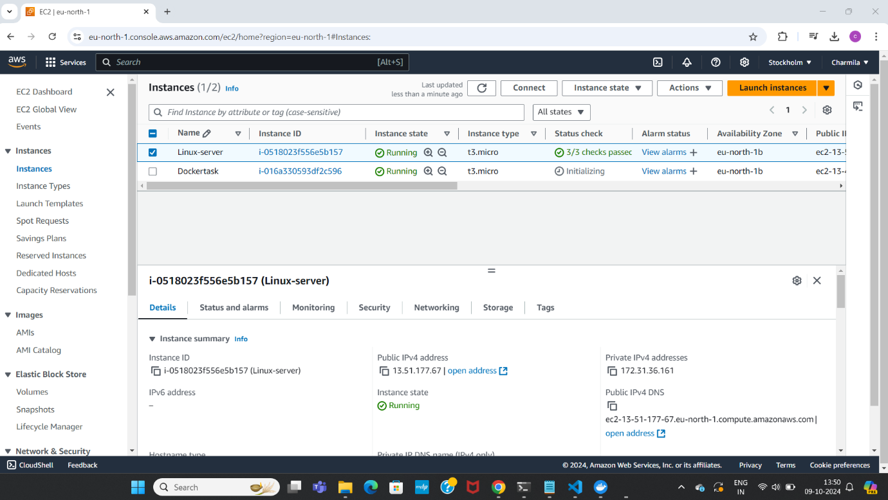

Established connection

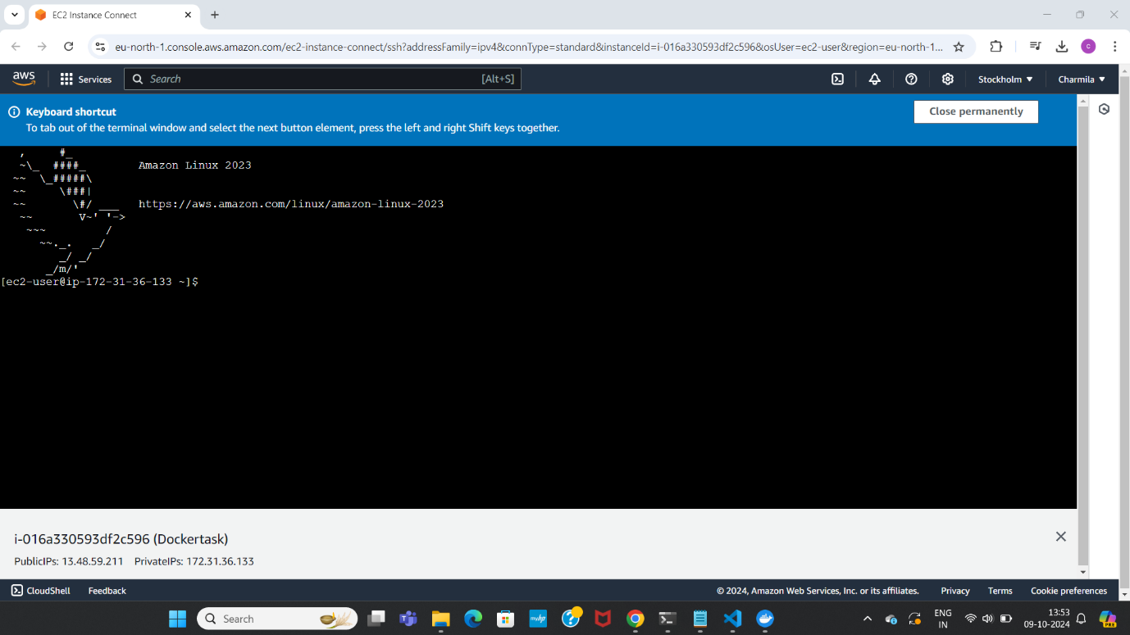

Installed docker using command

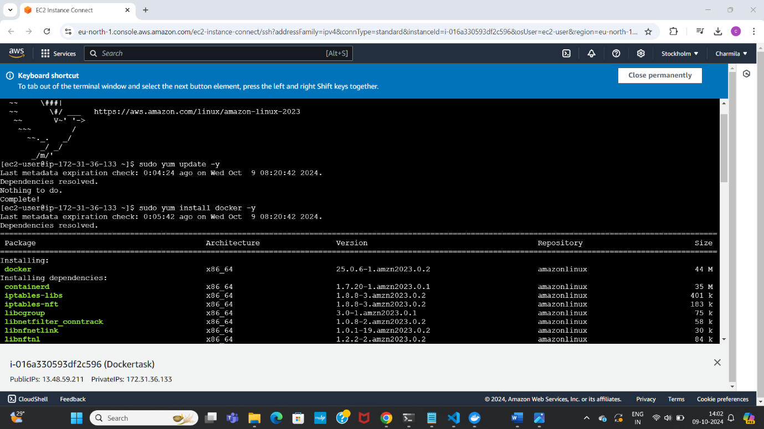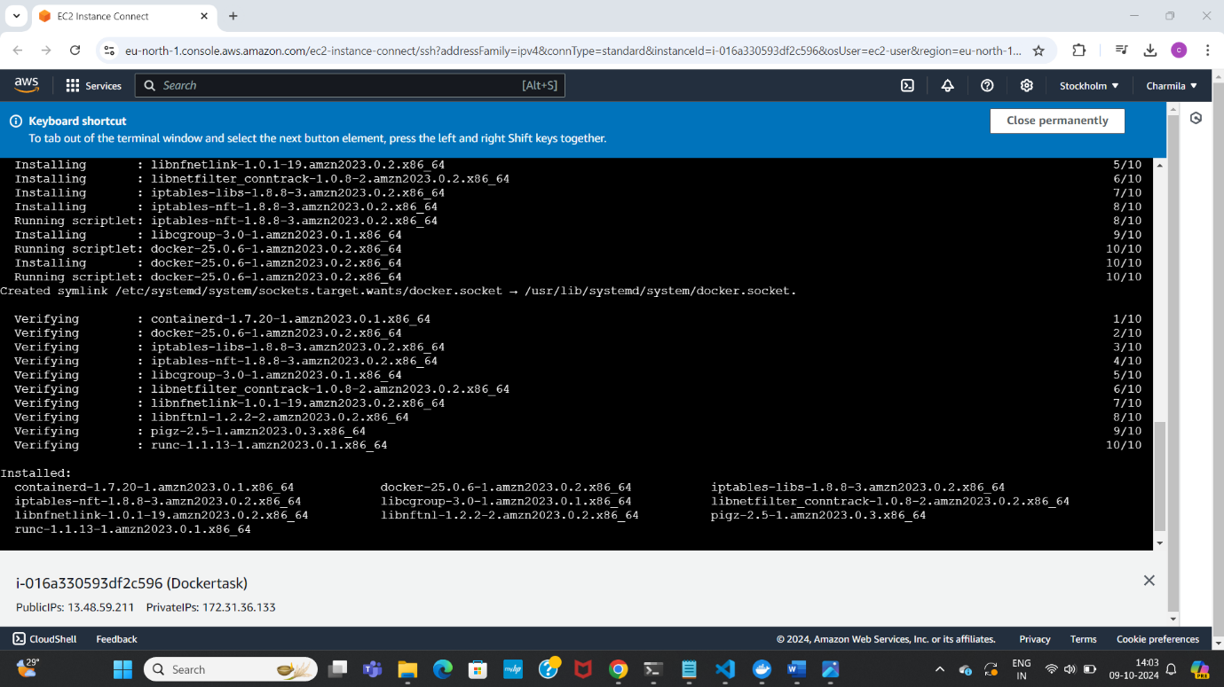

Used command sudo service docker start- to start/run the installed docker && Checked status using command- sudo service docker status

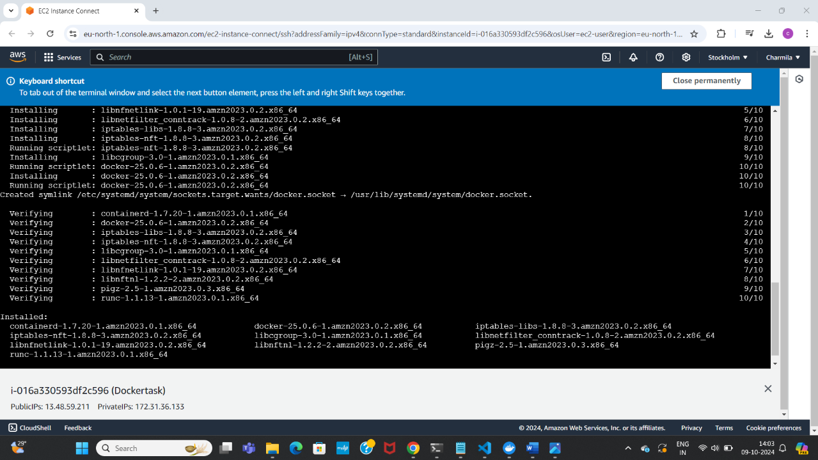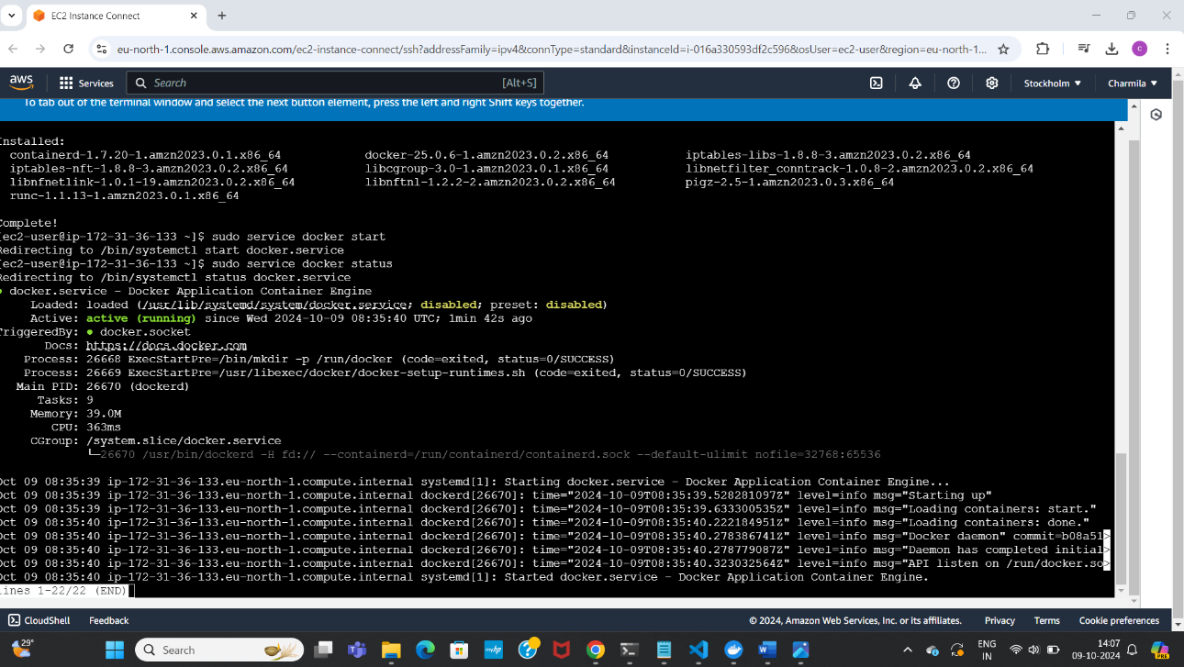

Tried to explore some basic docker commands as below:

Current Docker version installed:

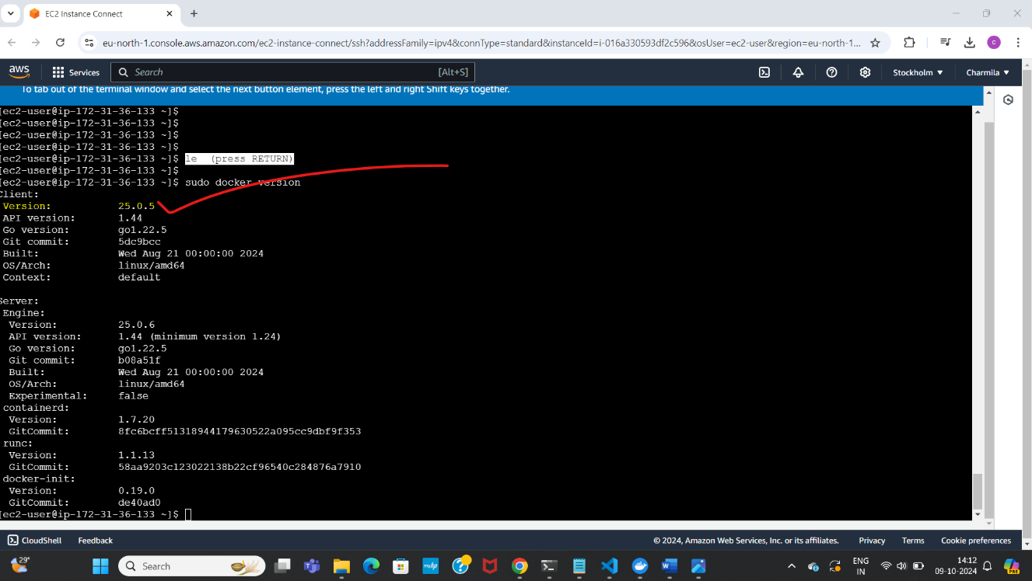

Pulled a docker image from online

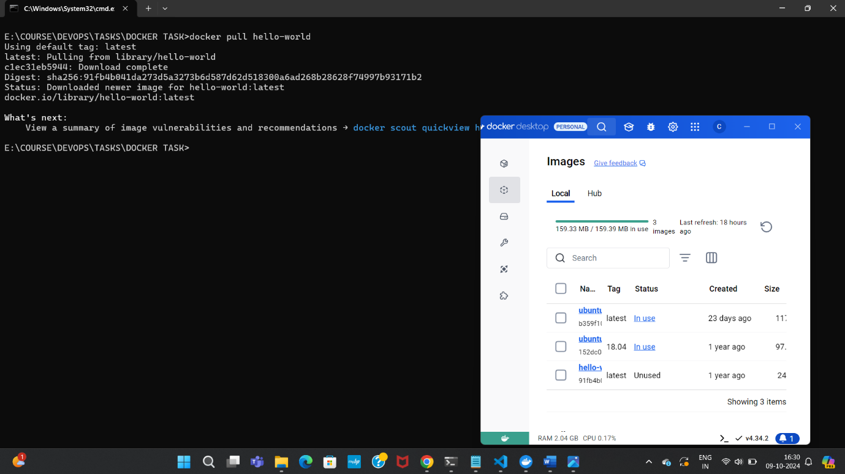

Run the docker image

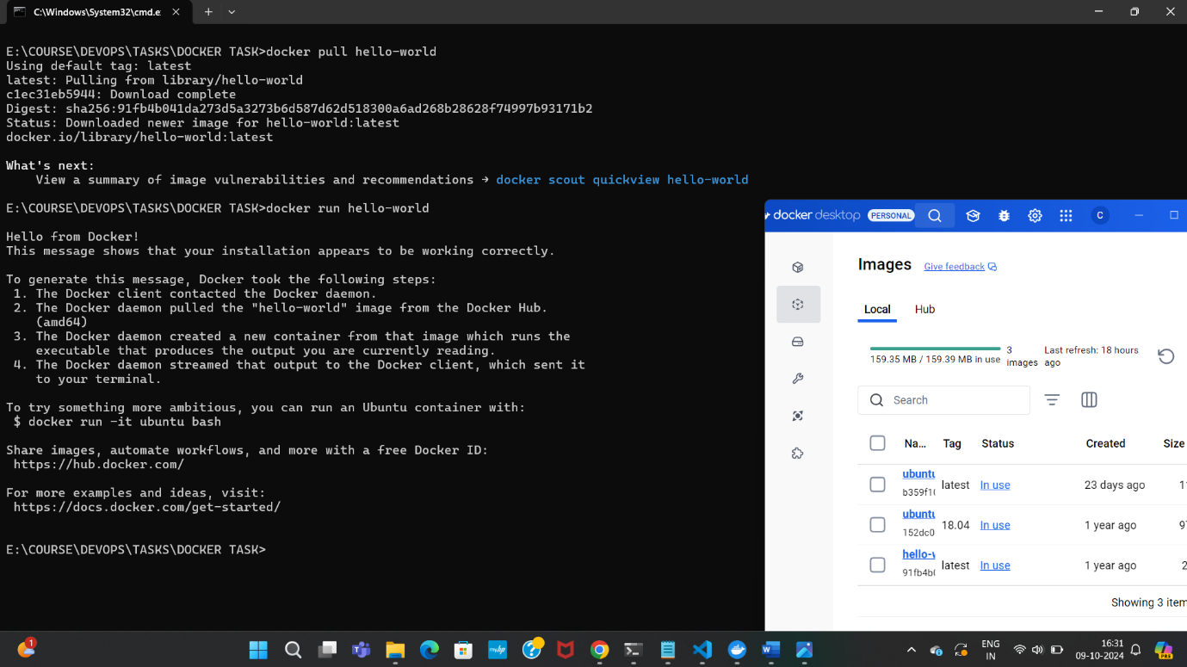

Command used to show current &all running containers/images in the system

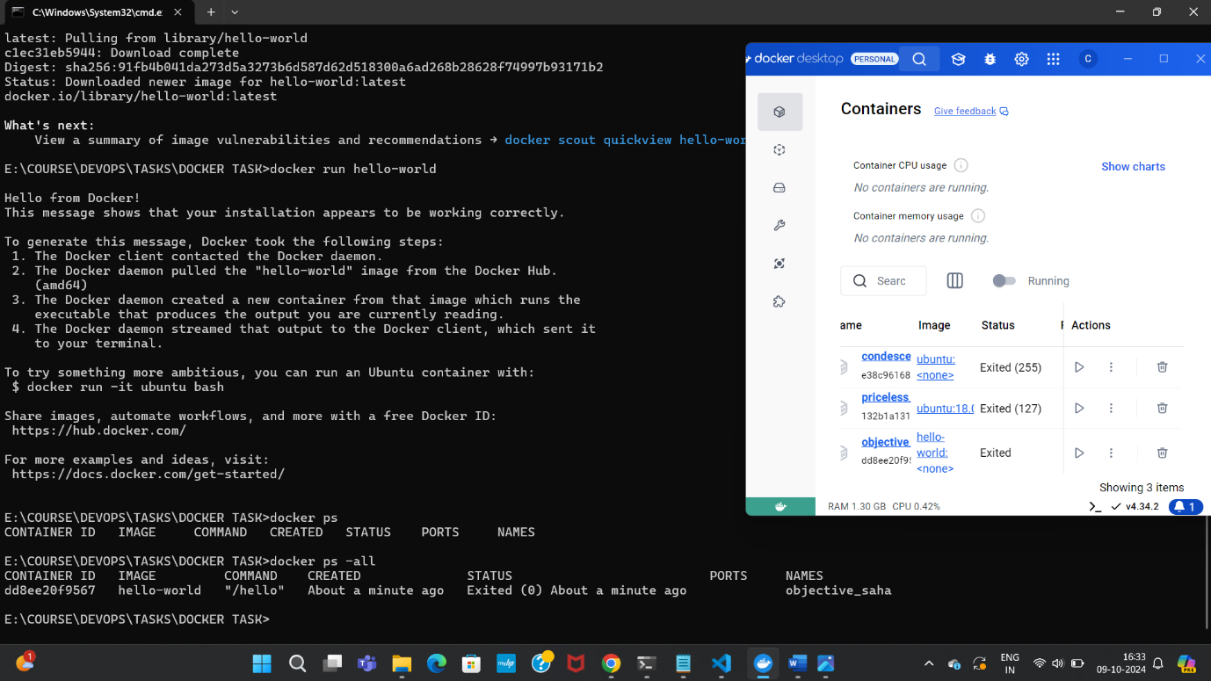

Removed a container and checked the status if it got removed

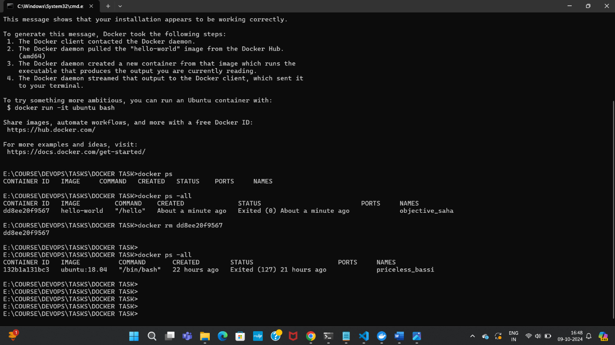

Docker volume

Docker create volume, Docker volume prune, Docker inspect volume, Docker volume rm, volumes list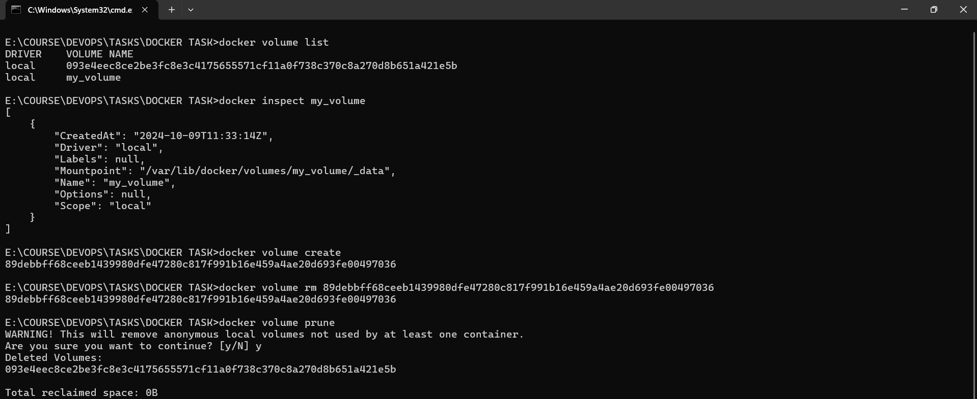

Explored some basic docker networking commands

To create a network, list the available network, to remove network, to remove unwanted network